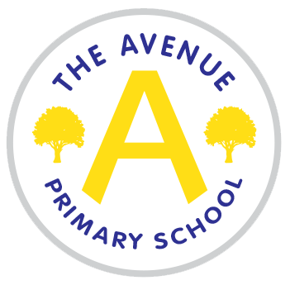
The Avenue Primary School
HEALTH CARE PLAN
Child’s name
D.O.B:
Address
Class / Year

Medical condition
Side effects
Parent/Guardian Contact Details:
Alternative family contact
G.P / paediatrician contact details

Any other relevant health professional

Any equipment needed
Staff training
Review and update

